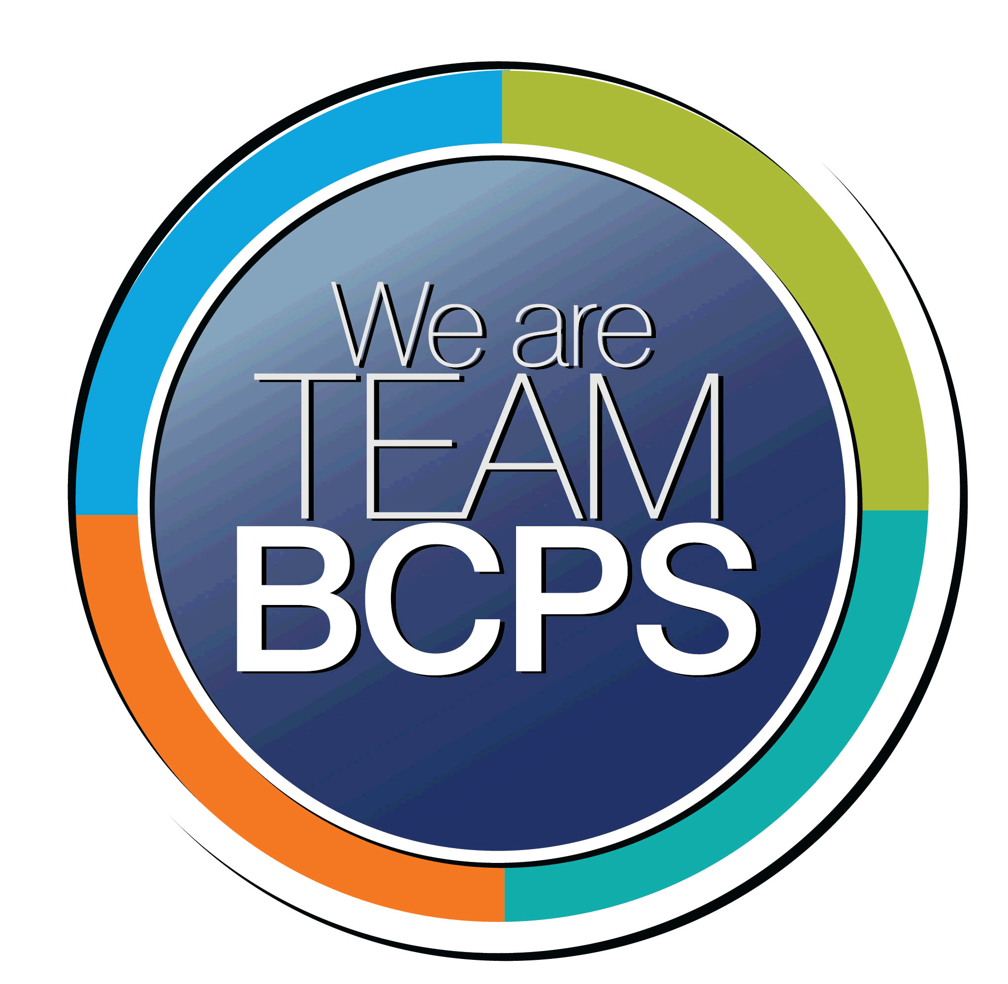 **Schoolwide Positive Behavior Plan** 

**Baltimore County Public Schools**

**Date Completed: 7/26/2023 School Year 2023-2024**

**School: Timber Grove Elementary School**

|  |
| --- |
| **Section 1: Initial Steps** |
|  |
| **School Climate Team** |
| *Identify members of a School Climate Team (consider a representative selection of members). The team meets initially to examine equity concerns and data and to develop the Schoolwide Positive Behavior Plan. The team should then meet monthly (minimum quarterly) to assess the effectiveness of the SWPBP on an ongoing basis.* |
| Administration  Classroom Teachers/ Educator Council Members  Special Education Representative  Special Areas Representative |
| **Equity Lens** |
| *Through an equity lens, identify what the data indicate about the social-emotional needs of students and the support provided by staff members relative to disproportionality between student groups, especially for African Americans or students receiving special education. Also consider the school’s population with regard to ELL, Latinx, and/or other student groups. (Information may be from School Data Story)* |
| Information from the school’s data story suggests that students of color, students receiving special education services, and English learners are populations that are consistently underserved. |
| **Data Analysis** |
| *Summarize what the data tell about the school climate. (Information from School Data Story)* |
| 2022-23 Stakeholder Survey Results  Student Responses  According to results from the *Belonging* section of the 2021 Stakeholder survey, approximately 82% of the 203 students who took the survey agreed or strongly agreed that they felt safe and welcomed at school (77%) and that students help each other (89%). Only 68% of students agreed or strongly agreed that students treat them with respect and almost 83% of students agreed or strongly agreed that students are accepting of other students. 71% of students surveyed responded that they agreed or strongly agreed that students work out disagreements by talking. The lowest score was in the area of students regulating emotions in which 40% of students agreed or strongly agreed that students stop and think before doing something when they get angry.  According to results from the *Student Support* section of the 2022 Stakeholder survey, around 87% of the 203 students surveyed agreed or strongly agreed that adults at the school care about them as a person and show them respect (84%). 85% of students agreed or strongly agreed that teachers listen to their ideas and 85% of students responded that they agreed or strongly agreed that there is at least one adult they can go to if they have a problem.  In the *Additional Questions* section of the Stakeholder survey, 29% of students reported that they have been bullied at school and 40% report that they have witnessed bullying at the school.  Parent Responses  According to results from the *Safety and Security* section of the 2022 Stakeholder survey, 70% of the 10 parents who responded to the survey agreed or strongly agreed that the school is safe and secure and 80% of parents agreed or strongly agreed that their child is treated with respect at school. 70% of parents agreed or strongly agreed that students at the school respect each other. 20% of parents agreed or strongly agreed that bullying is a problem at the school. Results from the *Communications* section of the survey show that 100% of parents agreed or strongly agreed that they feel welcome at the school. When asked if they would recommend this school to other parents/caregivers, 33% responded “definitely yes”, 44% responded “probably yes”, 22% responded “probably no” and 0.0% responded “definitely no”.  Staff Responses  According to results from the *Safety and Security* section of the 2022 Stakeholder survey, 93% of the 14 staff members who responded to the survey agreed or strongly agreed that they feel safe and secure at work. 79% of staff members agreed or strongly agreed that adults at the school respect each other and 50% agreed or strongly agreed that students at the school respect each other. About 65% of staff members disagreed or strongly disagreed that bullying was a problem at the school.  The results of staff specific questions about whether or not staff would send their child to the school or recommend the school to other parents/caregivers yielded the following results: 14%- “definitely yes”, 36%- “probably yes”, 42%- “probably not”, 7%- “definitely not” and when asked if respondents would recommend the school to a friend seeking employment 29% responded “definitely yes”, 43%- “probably yes”, 21%- “probably not” and 7%- “definitely not”. |
| **Climate Goals** |
| *Identify the school’s goals in improving the social-emotional climate of the building. (Information from School Progress Plan)* |
| Safe and Supportive Environment- Action Steps  - Teachers will center on students’ identities, strengths, interests, and needs in order to make instruction accessible.  - Educators will examine and interrogate their personal biases to become aware of the ways in which their own cultural experiences influence the conditions and learning opportunities that they create for students. |
| **Section 2: Developing and Teaching Expectations** |
|  |
| **Expectations Defined** |
| *Identify a School Code of Conduct with 3-5 positively stated school expectations. Develop a way to communicate the identified rules, based on the schoolwide expectations, for specific settings within the school building. Expectations should be clearly stated, communicated, taught, and frequently referenced.* |
| ROAR Pledge: As a Timber Grove Tiger, I pledge to make good choices and try my best. I am…  Respectful  Organize  Always Safe  Responsible and Ready  **In the Classroom this looks and sounds like:**  **Respectful**   * Speak kindly * Get permission to use someone else’s things * Work quietly * Cooperate with others     **Organized**   * Have all of your supplies ready * Keep your area clean * Turn your work in on time     **Always safe**   * Keep your hands, feet, and objects to yourself * Alert adults to unsafe situations     **Responsible and Ready**   * Be in your classroom by 8:20am * Follow teachers’/adults’ directions * Raise your hand to ask or answer * Complete your classwork and homework     **In the Halls and Stairways this looks and sounds like:**  **Respectful**   * Move silently * Open and close your locker quietly     **Organized**   * Carefully hold your belongings     **Always safe**   * Walk * Keep hands, feet, and objects to yourself     **Responsible and Ready**   * Stay in line * Face forward * Follow teachers’/adults’ directions     **In the Bathroom this looks and sounds like:**  **Respectful**   * Honor others’ privacy * Use quiet voices * Keep walls and stalls mark free     **Organized**   * Wait your turn patiently     **Always safe**   * Only stand on the floor * Lights must stay on * Wash hands * Keep hands and feet to yourself     **Responsible and Ready**   * Flush once * Put trash in cans only * Put toilet paper in toilet * Go to the bathroom in the toilet or urinal only     **In the Cafeteria this looks and sounds like:**  **Respectful**   * Wait patiently * Use soft voices * Lights off means stop talking * Follow teachers’/adults’ directions     **Organized**   * Bring your lunch or lunch money * Know your number * Get what you need the first time through     **Always safe**   * Keep hands, feet, and objects to yourself * Walk at all times * Stay seated     **Responsible and Ready**   * Clean your area * Put trash in cans * Raise your hand to get help     **In Recess this looks and sounds like:**  **Respectful**   * Use kind words * Share * Use good sportsmanship * Wait patiently for your turn     **Organized**   * Bring or wear sneakers * Wear appropriate clothing for play     **Always safe**   * Keep your shoes tied * Stay in your personal space * Be aware of other people * Walk around equipment, not under     **Responsible and Ready**   * Follow Playground Safety Rules * Alert teacher of unsafe play * Get help when someone is hurt     **In Arrival and Dismissal this looks and sounds like:**  **Respectful**   * Move and wait quietly in assigned area * Talk in low voices * Follow teachers’/adults’ directions     **Organized**   * Come with all of your belongings to go home * Keep all backpacks, lunch boxes, and instrument cases closed     **Always safe**   * Observe personal space * Alert adults to unsafe incidents * Exit in an orderly way     **Responsible and Ready**   * Go directly to your assigned dismissal area * Listen for your cue to leave school * Leave when it is your turn |
| **Classroom Plan for Teaching and Reinforcing Expectations, Routines, and Procedures** |
| *Teachers develop visuals to communicate culturally relevant classroom expectations, routines, and procedures based upon the schoolwide expectations. Educators explicitly teach expectations, routines, and procedures. The school staff recognize and reinforce expected and positive behavior. Teachers identify encouraging procedures and corrective procedures for their classrooms.* |
| ROAR Lesson Plans (suggested activities that are adapted by teachers to fit the needs of students at all levels in the elementary school building)  Classroom Teachers will break apart each characteristic of the school pledge, explore its definition and review with students what the stated behaviors look like in different parts of the building. Definitions of each of the words will be supplied so they are consistent across settings. The ROAR words will also be taught on the morning announcements.  Class expectations should be created and discussed as a class in order to create the type of environment conducive to safety and learning. A display of those expectations should then be created and posted for students and adults to refer to regularly.  If students have difficulty following cafeteria routines and procedures, then they will be sent to a buddy classroom to eat lunch until they have shown that they understand and can follow cafeteria expectations. Each class will establish a buddy classroom at the beginning of the school year in order to have a pre-determined location to be able to send students who demonstrate these challenges. |
| **Family/Community Engagement** |
| *Identify how the Schoolwide Positive Behavior Plan, the schoolwide expectations, and/or interventions will be communicated and shared with families. Consider how to include family and student voice in the initial plan and in evaluating the plan throughout the year.* |
| Back to School Night  Parent/ Family Nights  Student survey and small group feedback |
| **Section 3: Developing Interventions and Supporting Students** |
|  |
| **Resource Mapping of MTSS** |
| *Identify the evidence-based practices and interventions offered at Tier 1, Tier 2, and Tier 3 to support all students. Consider what culturally responsive interventions the school requires to meet the specific needs of the students.* |
| Tier 1: Restorative Practices, Conscious Discipline  Tier 2: interventions, such as small groups, will be established on a situational basis (Superflex, Conscious Discipline, Zones of Regulation, Second Step, Mentoring, etc.)  Tier 3: SST/504/IEP/BIP, revisit Tier 2 Resources/Interventions- personalize and individualize further |
| **Social-Emotional Learning** |
| *Identify the specific evidence-based social-emotional learning skill development practices the school will implement during the school year. Consider the importance of trauma-informed care, mental health awareness, level of students’ coping skills, etc. Determine how the social-emotional learning and the SEL competencies will be integrated into the school’s programming. Consider the need for any training the staff members may require.* |
| **Conscious Discipline**  Conscious discipline is a classroom management theory that focuses on changing the thoughts and reactions of the adults to help build the positive behaviors of the students. It is based around creating a school and classroom environment that feels like family. Conscious discipline lessons have been embedded into the curriculum for grades K-5. A resource to build more knowledge on Conscious Discipline is *Conscious Discipline: Building Resilient Classrooms* by Dr. Becky A. Bailey.  **Safe Space**  Each class will have a Safe Space. The Safe Space is student-selected and/or teacher guided for the purpose of calming and problem solving with a shared understanding that a variety of student emotions may be experienced. It is an area that should be used to teach and strengthen students’ self-regulation skills.  **Class Meetings**  Class meetings are used to build relationships. These discussions may be open to a child driven topic or a prompt from the teacher. It can also be used to discuss general class problems such as cafeteria behaviors or cleaning up after activities. Class meetings should be held daily. During this time the teacher, staff and/or students have the opportunity to discuss any problems that the class is facing and to come up with possible solutions. Along with identifying problems, teachers, staff and students will work together to solve problems.  **Student Support Request Forms**  Students will also be given access to student support request forms that they can use to request further support from the school counselor. The school counselor will review the procedures of how to use this form during regular classroom lessons. |
| **Character Education** |
| *Determine how specific evidence-based character education learning will be infused into the school’s programming to promote positive behavior and ethical decision-making. Character education will be culturally responsive and co-created with diverse stakeholders. Consider the need for any training the staff members may require.* |
| The language of virtues helps us to replace shaming and blaming with personal responsibility and respect. It is a frame of reference to foster academic excellence while creating a climate of care, as well as safety, trust and unity. It helps us to become the kind of people we want to be because language shapes character. Therefore, the way we speak and the words we use have great power to discourage or to encourage.  School-wide virtue resources, lessons and activities will be provided throughout the school year. The school counselor will also provide classroom lessons about character education.  Virtuous language will be infused in the morning announcements (bi-weekly) with accompanying resources for teachers to have classroom discussions about each virtue (read aloud, scenarios, personal connection, team building activity, etc.) |
| **Professional Development for Staff** |
| *Identify the professional development that will be offered to staff members throughout the year in order to support their knowledge, skill development, and implementation of the interventions selected, the character education learning, and social-emotional learning practices. Specify the schedule for professional development and how to obtain teacher feedback during the year to address their concerns and areas in which they want/need more information. (Information from School Progress Plan.)* |
| Professional development will be provided as needed during faculty and grade level meetings throughout the year. Grade level meetings are projected to be approximately once a month. Choice sections based in Conscious Discipline’s systems and structures will be offered to interested staff members as well. These types of meetings will be offered about three times during the year.  Staff feedback will be obtained through surveys, conversations, and during grade level and instructional leadership team meetings. |
| **Section 4: Supporting and Responding to Student Behavior** |
|  |
| **Recognitions/Incentives** |
| *Identify a variety of positive consequences, acknowledgements, recognitions, and/or incentives that are linked to the behavioral expectations and rules. Develop a system for implementing the positive acknowledgements consistently in school settings. Consider how to monitor who is being recognized and who is not being recognized and whether explicit or implicit biases may be occurring.* |
| Behavior Specific Praise and Acknowledgment  Classroom Celebration Systems- (specific to individual classes and their needs)- some ideas could include- class compliments, achieving daily/weekly goals set by the class, class currency, etc.  Orange Classroom Shout Out- in-class recognition of ROAR behavior  Green Teacher Acknowledgement- celebration with student chosen staff member  Pink Positive Referral- celebration with administration |
| **Hierarchy for Behavioral Referrals and Consequences** |
| *Identify the behaviors that are teacher-managed, behaviors referred to resource staff, and behaviors referred to administration. Refer to the BCPS Student Handbook for teacher and administrator-led interventions. Consider how unsafe behaviors will be addressed.* |
| **Teacher-Managed** **Behavior Procedures**  Teachers will keep their own documentation about situations that occur where students engage in the types of behavior as stated below. Teachers are expected to keep this documentation to show what happened, what was done in response and contact that was made home. The teacher needs to document not only the type of contact that was made home, but home’s response to the situation. The aspect of two-way communication with a family member/guardian to support the student is crucial.  If staff is expressing concerns that would lead to an office referral for repeated violations of the technology policy (TAUP), then there must be documentation of two-way communication with home. If challenging behavior is ongoing and staff is seeking support with a referral for continuous disruptive behavior, then there must be documentation of two-way communication with home and interventions that have been put in place.    **Teacher-Managed Offenses:**   * Refusal to follow a reasonable request * Out of assigned area/ classroom * Inappropriate language/comments * Inappropriate physical contact * Refusal to do class work * Inappropriate use of technology * Minor theft (property valued at under $10/ excludes cash)     **Possible Teacher’s Response/ Interventions:**   * Conference with student * Offer classroom safe space (positive phrasing- use as a tool) * Teacher “time out” (I message model) * Alternate seating * In class reflection sheet * Time in buddy class * Student mediation * Loss of privilege * Creation of a student specific goal * Behavior contract * Behavior chart * *Parent contact (see explanation above)*   **Office Referrals**  **Teacher Procedures**: Teachers will call the office for support and complete a referral as soon as possible**.** Support will arrive as soon as personnel are available. Every effort will be made to send someone to help support as soon as possible.    **Administrator/Designee Procedures:**Administrator/ Designee determines and implements consequences, and conferences with teacher by phone or in person before sending student back to class. Student will return to class when they demonstrate the ability to be safe and ready to learn. Decisions to keep students out of class will be determined on an individual basis. These decisions will be based on the student’s continued behavior and the circumstances involving the referral.  **Office Referral Offenses:**   * Use of profanity directed towards staff that results in disruption to learning * Fighting   - single student / multiple students   * Elopement (out of view of staff) * Specific verbal threat   - individual / multiple people / group   * Physically threatening behavior   - throwing dangerous items  - attempting to harm others   * Major theft (property valued at $10 or more/any cash)   Refer to the Teacher-Managed Offenses section above for further explanation about the expectations for the following type of referral:   * Multiple violations of Technology Acceptable Use Policy (TAUP) * Continuous disruptive behavior     **Possible Follow-Up/ Restorative Actions:**   * Conference with student * Reflection sheet * Loss of privilege * Mediation * Restorative conference * Class circle * Apology (written/ face to face) * Parent/Guardian contact * In Class Support * Time in Alternate Setting * Individualized instruction * Sensory input * Special assignment * BIP procedures * Detention * Parent/Guardian Conference * In-school suspension * Out of school suspension * Other |
| **Response for Intensive Behaviors** |
| *Identify a hierarchy of responses to intensive behaviors (i.e., emergency/crisis management/threat assessment/unsafe behaviors) including interventions and supports. Indicate which school staff members will respond as well as procedures and training as needed.* |
| Crisis Team- multiple staff members trained in CPI  Threat assessments will be conducted by the school counselor, school social worker or school psychologist if the need arises.  An emergency petition (EP) will be completed by qualified personnel if he/she deems the student presents a danger to the life and safety of the individual or others. |
| **Monitoring the Schoolwide Positive Behavior Plan/Data Analysis** |
| *Identify the data that will be collected and reviewed by the School Climate Team in order to identify behavior trends, patterns, action steps, and interventions using a problem-solving strategy. Consider having a uniform referral form for staff to complete to document referrals to administration. Consider how teachers should document classroom-managed concerns/behaviors/difficulties. (Information from School Progress Plan.)* |
| Office Referrals |
| **Section 5: Miscellaneous Content/Components** |
| **Click or tap here to enter text.** |